**User manual**

**By**

**Bayan Yahia  
Adeeb Ganadry**

To access InsightPredict, open the website and click on the Login button. If you have an account enter your email and password then click Log In if you're a new user select Sign Up.



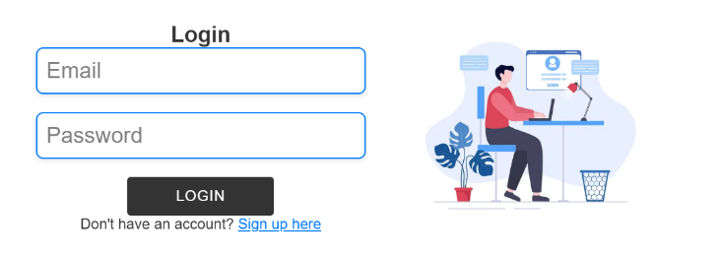

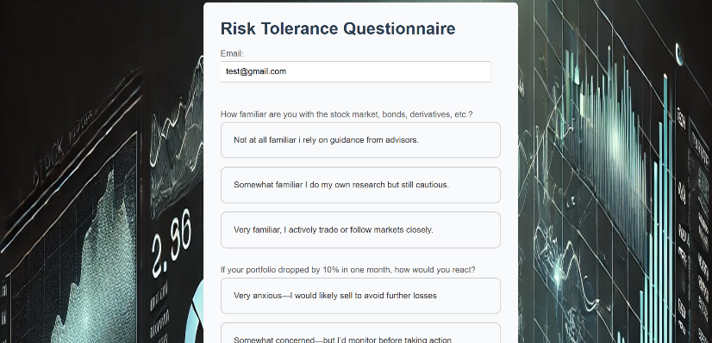

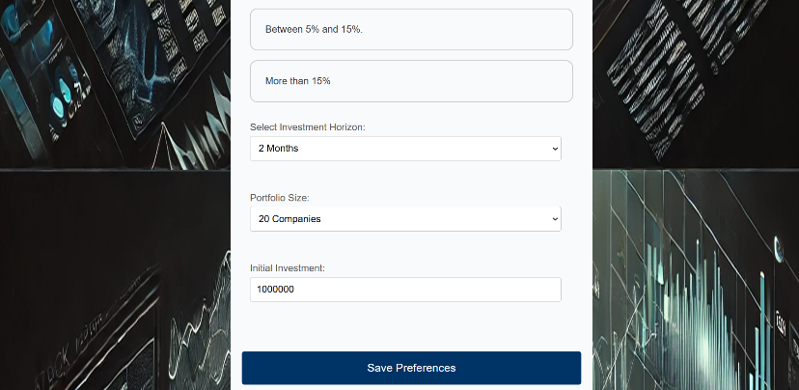

Fill in your details, answer the investment preference questions, and click **Save Preferences** to create your account.

Once logged in, you can access the following options from the left-side menu:

* Dashboard: View your portfolio performance, stock rankings, and key insights.
* User Preference: Update your investment preferences, such as risk tolerance and portfolio goals.
* News and Insights: Stay updated with the latest stock market news and trends.
* Interactive Tools: Access tools for stock analysis and portfolio management.
* Contact Us: Reach out for support or provide feedback.
* Logout: Safely exit your account.

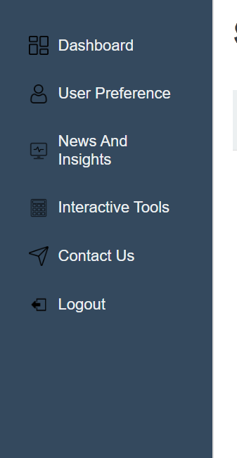

Interactive Tools:

Stock Calculator: Allows users to calculate potential earnings based on the stock symbol, number of shares, and initial investment.

Stock Comparison Tool: Compares performance trends of selected stocks, helping users make informed decisions.

Investment Simulator: Simulates portfolio management by enabling users to buy/sell stocks and visualize portfolio allocation with dynamic charts.



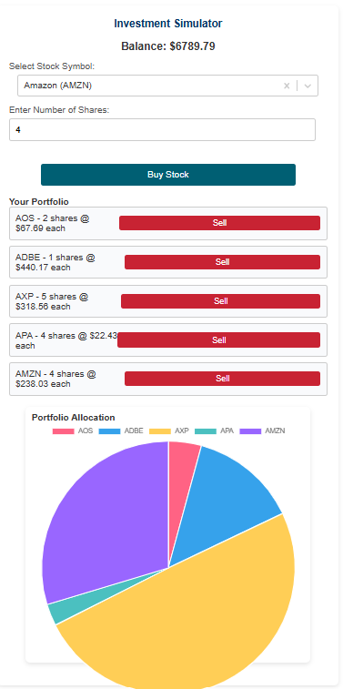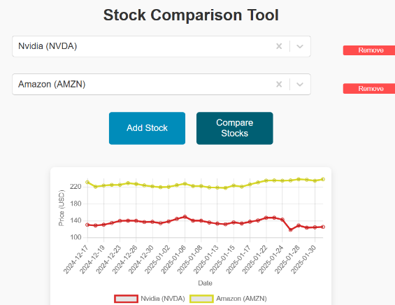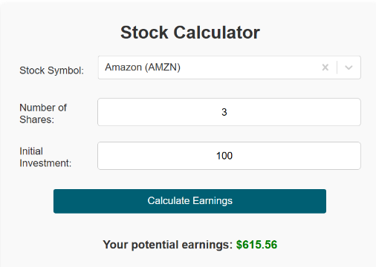



**News and Insights:**

Displays the latest stock market updates and news headlines, helping users stay informed about trends and events affecting their investments.